Algebra 1: Unit 13, Lesson 11

- A table of values for a function is shown.
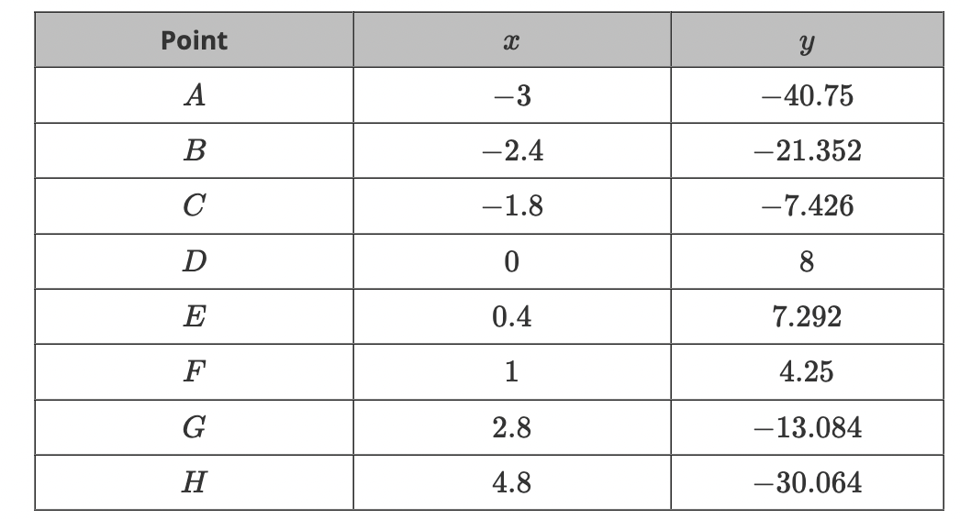
What is the average rate of change between points $G$ and $H$? Round your answer to the nearest hundredth.
$$-8.49$$

- The graph of a function with points $(-1,1)$ and $(2,4)$ is shown on the coordinate grid.
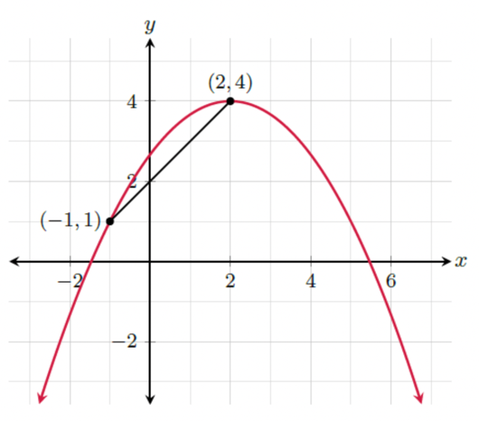
What is the slope of the secant line between the given points?
$$1$$

- What is the slope between the points $(1,-0.9)$ and $(-6,-15.6)$?
$$2.1$$

